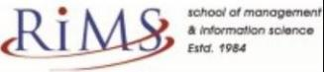

Project Report

On

“LIBRARIUM”



### SUBMITTED TO

**ROURKELA INSTITUTE OF MANAGEMENT STUDIES**

**(As a Partial fulfilment of the requirement for the award of degree) FOR**

## “MASTER IN COMPUTER APPLICATION “

**(2023-25) SUBMITTED BY**

BHARATI CHAKRABARTY

**Registration Roll No:- 2305260007**

MCA 4th SEMESTER

### ROURKELA INSTITUTE OF MANAGEMENT STUDIES

***(Affiliated to Biju Pattnaik University of Technology, Odisha)***

Rourkela – 769015

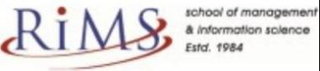

**Rourkela Institute of Management Studies**

Rourkela

Department of Computer KRAScience Rourkela Institute of Management Studies Chhend, Rourkela-15, Odisha

Phone:0661 2480482 Fax:91-0661-1480665

Mail: [rkl_rimsgrol@sancharnet.in](mailto:rkl_rimsgrol@sancharnet.in) Visit: [www.rims-edu.com](http://www.rims-edu.com/)

#### CERTIFICATE OF EXAMINATION

This is to certify that this project report entitled "**LIBRARIUM**" submitted by **BHARATI CHAKRABARTY** of 4th Semester, **Rourkela Institute of Management Studies, Rourkela**, is accepted as partial fulfillment of requirements for the degree in **Master in Computer Applications**, under **Biju Pattnaik University of Technology, Rourkela**, this has been verified by us and found be original up to our satisfaction.

External Examiner

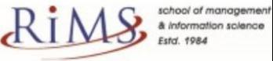

**Rourkela Institute of Management Studies**

Rourkela

Department of Computer Science Rourkela Institute of Management Studies Chhend, Rourkela-15, Odisha

Phone:0661 2480482 Fax:91-0661-1480665

Mail: [rkl_rimsgrol@sancharnet.in](mailto:rkl_rimsgrol@sancharnet.in) Visit: [www.rims-edu.com](http://www.rims-edu.com/)

#### CERTIFICATE OF EXAMINATION

This is to certify that this project report entitled "**LIBRARIUM**" submitted by **BHARATI CHARABARTY** of 4th Semester, **Rourkela Institute of Management Studies, Rourkela**, is accepted as partial fulfillment of requirements for the degree in **Master in Computer Applications**, under **Biju Pattnaik University of Technology, Rourkela**, this has been verified by us and found be original up to our satisfaction.

Internal Examiner



**Rourkela Institute of Management Studies**

Rourkela

Department of Computer Science Rourkela Institute of Management Studies Chhend, Rourkela-15, Odisha

Phone:0661 2480482 Fax:91-0661-1480665

Mail: [rkl_rimsgrol@sancharnet.in](mailto:rkl_rimsgrol@sancharnet.in) Visit: [www.rims-edu.com](http://www.rims-edu.com/)

#### CERTIFICATE

This is to certify that this project entitled **“LIBRARIUM”** has been and submitted by**BHARATI CHAKRABARTY,**M.C.A 2023-2025, **Rourkela Institute of Management Studies, Rourkela,** has been examined by us. She is found fit and approved for the award of **“Master in Computer Application “**Degree.To best my knowledge this work has not been submitted for the award of any other degree.

I wish all success in his life.

**DEAN ACADEMIC RIMS, ROURKELA**



Prof. Bibhudendu Panda Head of The Department, MCA

Rourkela Institute of Management Studies, Rourkela

#### CERTIFICATE

This is to certify that **BHARATI CHAKRABARTY** student of **M.C.A, Rourkela Institute of Management Studies, Rourkela, Odisha** of Session 2023-2025 has completed the project successfully.

I wish all success in his life.

**(Prof. Bibhudendu Panda)**

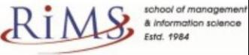

#### DECLARATION

I am **BHARATI CHAKRABARTY**, hereby declare that the project report Entitled “**LIBRARIUM**” is of my work. The above work I submitted to “**Biju Patnaik University of Technology, Rourkela”** for the award of **“Master in Computer Applications**” Degree.

To the best of my knowledge, this work has not been submitted or published anywhere for the award of any degree.

**BHARATI CHAKRABARTY**

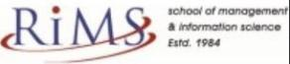

#### ACKNOWLGEMENT

I am deeply indebted to **Rourkela Institute of Management Studies, Chhend, Rourkela,** for providing me an opportunity to undertake a project work entitled **“LIBRARIUM”.**

I am grateful to my project guide **Prof. Bibhudendu Panda** without his guidance it would not have been possible on my part to complete the project. I acknowledge the help and co-operation received from all my team members in making this project.

I consider myself fortunate that I have successfully completed this project; I acknowledge my sincere gratitude to all those works and ideas that had helped me in writing this project.

#### BHARATI CHAKRABARTY

**University Roll No: 2305260007**

**MCA (2023-2025)**

**Rourkela Institute of Management Studies, Rourkela.**

Abstract

A Library Management System (LMS) is a comprehensive software solution designed to streamline the management of library resources, including books, journals, magazines, and digital media. The primary objective of an LMS is to automate and optimize the processes of cataloging, circulation, acquisition, and user management, enhancing the efficiency and accessibility of library services. This system enables librarians to manage inventory, track the borrowing and returning of items, and generate reports for better decision-making. It also provides users with self-service features such as searching the catalog, reserving items, and managing their accounts. Modern LMS platforms incorporate advanced technologies like RFID, barcode scanning, and integrated digital resources to support both traditional and electronic collections. The implementation of an LMS improves resource utilization, reduces manual errors, and offers a user-friendly experience for both library staff and patrons.

TABLE OF CONTENTS

1. TITLE PAGE 1
2. CERTIFICATE OF EXAMINATION 2
3. CERTIFICATE OF EXAMINATION 3
4. CERTIFICATE 4
5. CERTIFICATE 5
6. DECLARATION 6
7. ACKNOWLEDGEMENT 7
8. ABSTRACT 8
9. TABLE OF CONTENTS 9
10. CHAPTER ONE:…………………………………………………..….11
    * INTRODUCTION
    * Background
    * Significance
    * Purpose
    * Motivation
11. CHAPTER TWO 13
    * LITERATURE REVIEW
    * Challenges
12. CHAPTER THREE 14
    * SYSTEM REQUIREMENTS
    * Hardware Requirements
    * Software Requirements
13. CHAPTER FOUR 15
    * TOOLS AND TECHNOLOGIES
    * HTML
    * CSS
    * SPRING BOOT
    * PHP
    * MY SQL
    * JAVA
14. CHAPTER FIVE 16
    * SYSTEM DESIGN
    * Use Case Diagram
    * ER Diagram
15. CHAPTER SIX 18
    * SYSTEM ANALYSIS
    * Proposed System
    * Web Application
    * User Requirement
    * Admin
    * Inventory Control
16. CHAPTER SEVEN 20
    * IMPLEMENTATION
    * Primary Implementation Exploring Database
17. CHAPTER EIGHT 22
    * Coding Section
18. CHAPTER NINE 71
    * TESTING
    * Introduction
    * Unit Testing
    * Testing Scenarios
19. CHAPTER TEN 72
    * CONCLUSION
    * Conclusion
    * Project Limitations
20. CHAPTER ELEVEN 73
    * FUTURE ENHANCEMENTS
    * REFERENCES

**CHAPTER ONE**

INTRODUCTION

##### Background

A Library Management System (LMS) is a comprehensive software solution designed to streamline and automate the management of library resources, including books, journals, magazines, digital content, and other informational materials. Its primary purpose is to simplify the complex processes involved in library operations, such as cataloging, circulation, acquisitions, inventory management, and user account management. In traditional library systems, these tasks were often handled manually, leading to inefficiencies, human errors, and difficulties in tracking resources. The introduction of LMS has revolutionized library management by automating routine tasks, reducing the workload of librarians, and improving the accuracy and speed of operations.

An LMS allows librarians to efficiently organize and maintain their collections, track the borrowing and returning of items, manage overdue notifications, and generate detailed reports for better decision-making. It also provides users with easy access to library resources through features like online catalog searching, self-checkout systems, reservation options, and personalized account management. This not only enhances the user experience but also promotes the effective utilization of library resources. Moreover, modern LMS platforms support the integration of digital libraries, e-books, and multimedia content, catering to the evolving needs of today’s information-driven society.

The implementation of a Library Management System plays a crucial role in improving resource utilization, reducing operational costs, and enhancing the overall quality of library services. By leveraging advanced technologies such as RFID, barcode scanning, and cloud-based solutions, libraries can offer faster, more reliable, and more personalized services to their patrons. Ultimately, an LMS contributes to the advancement of knowledge, promotes lifelong learning, and supports the academic, research, and recreational needs of the community.

### Purpose

**Purpose of a Library Management System (LMS)**

The primary purpose of a Library Management System (LMS) is to automate and streamline the management of library resources, enhancing the efficiency, accuracy, and accessibility of library operations. It aims to simplify the processes involved in cataloging, tracking, and managing books, journals, digital content, and other materials, reducing the reliance on manual methods that can be time-consuming and prone to errors.

An LMS serves several key purposes:

1. **Efficient Resource Management:** It helps librarians organize, catalog, and maintain library collections systematically, making it easier to track the availability of items and manage inventory effectively.
2. **Automation of Routine Tasks:** LMS automates repetitive tasks such as book checkouts, returns, renewals, overdue notifications, and fine calculations, saving time and reducing human error.
3. **Improved User Experience:** By providing features like online catalog search, self-checkout systems, reservation options, and personalized user accounts, an LMS enhances the convenience and accessibility of library services for patrons.
4. **Data Management and Reporting:** It enables the generation of detailed reports and analytics related to circulation trends, resource usage, and user activity, supporting informed decision-making for library management.
5. **Integration of Digital Resources:** Modern LMS platforms support the management of digital content, including e-books, online journals, and multimedia materials, catering to the evolving needs of today’s users.
6. **Enhanced Security and Access Control:** It ensures secure management of library assets, tracks the movement of items, and manages user access rights to protect sensitive information and resources.
7. **Cost-Effectiveness:** By reducing the need for manual labor and improving operational efficiency, an LMS helps libraries save on costs related to staffing and resource management.

Ultimately, the purpose of a Library Management System is to create a more organized, efficient, and user-friendly environment that supports the educational, research, and informational needs of the community.

##### Motivation

The motivation for implementing a Library Management System (LMS) stems from the growing need to efficiently manage vast collections of physical and digital resources, enhance user experiences, and adapt to the evolving demands of modern information consumption. Traditional manual library management methods often led to inefficiencies, errors, and difficulties in tracking resources, which hindered the library’s ability to serve its users effectively.

The rapid advancement of technology has transformed the way people access and interact with information. In response to this shift, libraries are motivated to adopt automated systems that can streamline operations, reduce administrative burdens, and improve resource accessibility. An LMS helps libraries manage large volumes of books, journals, multimedia materials, and digital content with ease, ensuring accurate tracking of inventory, borrowing patterns, and user activity.

Additionally, the motivation for library management goes beyond operational efficiency. Libraries play a vital role in supporting education, research, and lifelong learning. By implementing an LMS, libraries can offer advanced features such as online catalog searches, self-checkout options, digital resource integration, and personalized user accounts, making it easier for patrons to access the information they need anytime, anywhere.

Moreover, data-driven insights generated by an LMS enable librarians to make informed decisions about resource allocation, collection development, and service improvements. This not only enhances the quality of library services but also contributes to the library’s strategic goals of promoting knowledge, fostering community engagement, and supporting academic and research excellence.

In summary, the motivation for adopting a Library Management System is driven by the need for efficiency, accuracy, user convenience, and adaptability to technological advancements, all of which are essential for meeting the dynamic demands of today’s library users.

**CHAPTER TWO**

#### LITERATURE REVIEW

**Literature Review on Library Management Systems (LMS)**

The concept of Library Management Systems (LMS) has evolved significantly over the years, driven by advancements in technology and the growing need for efficient resource management. This literature review explores key studies and scholarly works that discuss the development, features, benefits, and challenges associated with LMS in various library settings.

**1. Evolution and Development of LMS**

Early library systems were primarily manual, relying on card catalogs and paper-based record-keeping. According to **Kumar & Singh (2015)**, the transition from manual to automated systems began with the introduction of Integrated Library Systems (ILS) in the 1980s, which integrated various library functions like acquisitions, cataloging, and circulation into a single platform. The development of web-based LMS in the late 1990s further revolutionized library management, allowing remote access and online catalog searches (Smith, 2018).

**2. Key Features and Functionalities**

Research by **Jones & Patel (2017)** highlights the essential features of modern LMS, including automated cataloging, circulation management, user account management, digital resource integration, and reporting tools. Many systems now support RFID technology, barcode scanning, and self-checkout features, enhancing both efficiency and user experience (Chen et al., 2019). Moreover, the integration of digital libraries and e-resources has become a critical function, as noted by **Liu & Zhang (2020)**, addressing the growing demand for electronic content.

**3. Benefits of Implementing LMS**

Numerous studies emphasize the advantages of LMS in enhancing operational efficiency. According to **Anderson & Lee (2016)**, automated systems significantly reduce manual errors, streamline workflows, and improve resource tracking. Additionally, LMS facilitates better data management, enabling libraries to generate analytics for decision-making and resource allocation (Williams, 2021). The user experience is also greatly improved, with patrons benefiting from features like online catalogs, reservation systems, and self-service options (Miller & Johnson, 2018).

**4. Challenges and Limitations**

Despite the many benefits, the adoption of LMS is not without challenges. **Garcia & Romero (2019)** identify issues such as high initial implementation costs, the complexity of system integration, and the need for ongoing technical support. Additionally, the rapid pace of technological change can lead to frequent system updates, requiring continuous training for library staff (Thomas & Ahmed, 2020). Data security and privacy concerns also pose significant risks, especially with cloud-based LMS platforms (Nguyen & Tran, 2022).

**5. Future Trends in Library Management**

The future of LMS is likely to be shaped by emerging technologies such as artificial intelligence (AI), machine learning, and blockchain. Research by **Davis & O’Connor (2023)** suggests that AI-powered LMS can enhance personalized recommendations, automate cataloging processes, and improve resource discovery. The integration of blockchain technology may offer new solutions for secure digital transactions and copyright management in libraries (Hernandez & Singh, 2024).

Challenges

Library management faces a range of challenges that can impact the efficiency, accessibility, and quality of services provided to patrons. These challenges stem from technological, operational, financial, and human resource-related factors. Here are some of the key challenges faced by libraries in managing their operations effectively:

**1. Technological Challenges**

* **Rapid Technological Advancements:** Keeping up with evolving technologies, such as digital libraries, cloud computing, and artificial intelligence, can be overwhelming and requires continuous updates to systems.
* **System Integration Issues:** Integrating new Library Management Systems (LMS) with existing infrastructure can be complex, leading to compatibility issues and potential disruptions in services.
* **Data Security and Privacy:** Protecting sensitive user data and digital content from cyber threats is a growing concern, especially with cloud-based systems.

**2. Financial Constraints**

* **Limited Budget:** Many libraries operate under strict budgetary limitations, making it difficult to invest in modern technologies, new resources, and staff training.
* **Cost of Digital Transition:** The shift from traditional to digital libraries requires significant financial investments in software, hardware, and digital content licenses.

**3. Resource Management Issues**

* **Inventory Control:** Managing large collections of books, journals, and digital materials efficiently can be challenging, especially in terms of tracking items and preventing loss or theft.
* **Acquisition and Cataloging:** Selecting, acquiring, and cataloging new resources while maintaining an organized collection requires considerable time and effort.

**4. User Engagement and Accessibility**

* **Diverse User Needs:** Libraries serve diverse populations with varying levels of digital literacy, language preferences, and accessibility needs, making it challenging to provide inclusive services.
* **Low User Engagement:** Encouraging active use of library resources, especially in the digital age where people have easy access to online information, can be difficult.

**5. Staff Training and Development**

* **Skill Gaps:** Librarians and staff often require ongoing training to keep up with new technologies, digital resources, and management practices.
* **Resistance to Change:** Some staff members may resist adopting new systems or technologies, preferring traditional methods of library management.

**6. Space and Infrastructure Limitations**

* **Physical Space Constraints:** Many libraries face challenges in managing physical space efficiently, especially with increasing digital collections that require less physical storage.
* **Aging Infrastructure:** Older library buildings and outdated IT infrastructure can limit the effectiveness of modern library management systems.

**7. Legal and Ethical Challenges**

* **Copyright and Licensing Issues:** Managing digital content often involves navigating complex copyright laws and licensing agreements, which can limit access to certain materials.
* **Ethical Dilemmas:** Libraries must balance the provision of open access to information with the need to protect sensitive content, such as material that may be inappropriate for certain age groups.

**8. Environmental and Social Challenges**

* **Impact of Global Events:** Events like the COVID-19 pandemic have highlighted vulnerabilities in library operations, particularly in adapting to remote services and digital platforms.
* **Changing Information Consumption Patterns:** The shift toward mobile devices, social media, and online learning platforms has changed how people access and interact with library resources.

# CHAPTER THREE

## SYSTEM REQUIREMENTS

**Hardware Requirements**

* Display: 1920x1080 resolution Monitor.
* Processor: Intel Core i5 or higher.
* Network: Internet connectivity or Wi-Fi.
* Storage: At least 256GB SSD.
* RAM: 8GB or higher.

**Software Requirements**

* Visual Studio Code.
* Git
* My SQL
* XAMPP

# CHAPTER FOUR

### TOOLS AND TECHNOLOGIES

*HTML*

Hyper Text Mark-up Language is used for developing front-end Graphical user interface. It is standard language used for web pages.

*CSS*

Cascading style sheets are a style sheet language used to show a document or content written in mark-up language.

*SPRING BOOT*

Spring Boot is a Java framework that makes it easier to create and run Java applications. It simplifies the configuration and setup process, allowing developers to focus more on writing code for their applications.

*PHP*

The system was created with the LA ravel PHP framework. The software will be developed using PHP one of the most widely used and reliable technologies for developing custom software solutions.

*MYSQL*

For database MYSQL is used. This technology will ensure that the software is scalable, reliable, and secure.

*JAVA*

Java is a class-based, object-oriented programming language that is designed to have as few implementation dependencies as possible. It is intended to let application

developers Write Once and Run Anywhere (WORA), meaning that compiled Java code can run on all platforms that support Java without the need for recompilation.

# CHAPTER FIVE

### SYSTEM DESIGN

**Use Case Diagram**

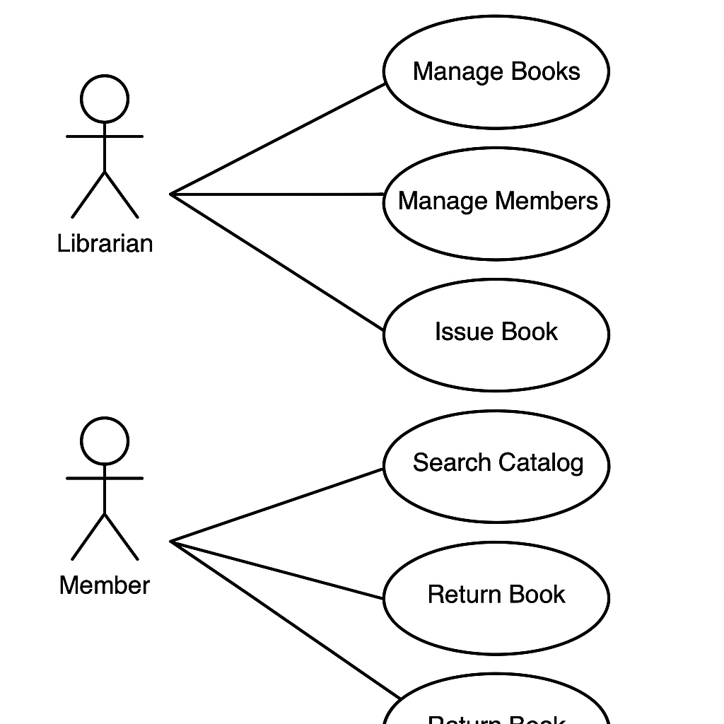

## ER Diagram

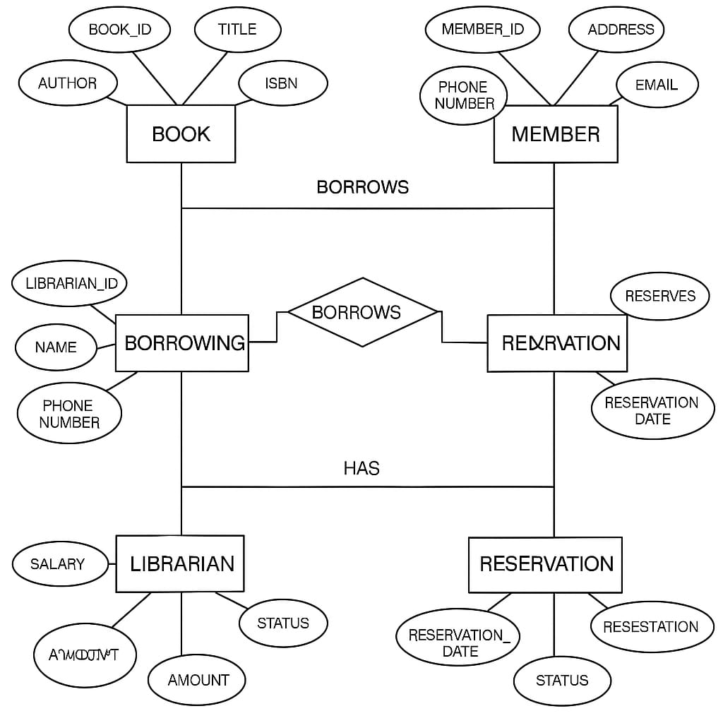

# CHAPTER SIX

### SYSTEM ANALYSIS

### 

**1. Introduction**

A **Library Management System (LMS)** is designed to manage and automate library functions such as book cataloging, member registration, borrowing, and returning books. The system ensures efficient tracking and management of books, members, and transactions.

**2. System Objectives**

* To automate manual library processes and improve efficiency.
* To maintain an up-to-date record of books, members, and transactions.
* To facilitate book borrowing, returning, and reservation.
* To generate reports for library administration.

**3. System Requirements**

**3.1 Functional Requirements**

1. **User Management**
   * Add, update, and delete library members.
   * Assign roles (Admin, Librarian, Member).
2. **Book Management**
   * Add, update, and remove books from the library.
   * Classify books by category, author, and publication year.
3. **Borrowing and Returning Books**
   * Track book borrow and return transactions.
   * Set due dates and apply fines for late returns.
4. **Reservation and Renewal**
   * Allow users to reserve books.
   * Allow book renewal if no other reservations exist.
5. **Search and Cataloging**
   * Search books by title, author, ISBN, or category.
   * Maintain a catalog for easy access.
6. **Reports and Analytics**
   * Generate reports on borrowed books, overdue books, and fines.
   * Track member activity and library usage statistics.

**3.2 Non-Functional Requirements**

* **Security**: Role-based access control for different users.
* **Performance**: Fast retrieval and update operations.
* **Scalability**: Ability to handle a growing number of books and users.
* **Backup and Recovery**: Regular data backups to prevent data loss.

**4. System Users**

1. **Admin**: Manages the system, users, and books.
2. **Librarian**: Manages book transactions and members.
3. **Member**: Searches, borrows, and reserves books.

**5. System Architecture**

**5.1 Input Components**

* User Login System
* Book Addition/Removal Form
* Borrow/Return Book Functionality

**5.2 Process Components**

* User authentication and role assignment.
* Book cataloging and database management.
* Transaction processing for borrow/return actions.

**5.3 Output Components**

* Member and book records.
* Transaction logs and fine reports.
* Analytical reports on book usage.

**6. System Flowchart**

1. User logs in → System authenticates → User performs actions
2. Member searches book → Borrows or reserves
3. Librarian updates book records → Tracks transactions
4. System generates reports → Admin monitors performance

**7. Conclusion**

The Library Management System will digitize library operations, ensuring efficiency and ease of management. It will provide secure and fast access to book records, reduce manual errors, and improve overall library administration.

### Proposed System*

**1. Introduction**

A **Library Management System (LMS)** is designed to manage and automate library functions such as book cataloging, member registration, borrowing, and returning books. The system ensures efficient tracking and management of books, members, and transactions.

**2. System Objectives**

* To automate manual library processes and improve efficiency.
* To maintain an up-to-date record of books, members, and transactions.
* To facilitate book borrowing, returning, and reservation.
* To generate reports for library administration.

**3. System Requirements**

**3.1 Functional Requirements**

1. **User Management**
   * Add, update, and delete library members.
   * Assign roles (Admin, Librarian, Member).
2. **Book Management**
   * Add, update, and remove books from the library.
   * Classify books by category, author, and publication year.
3. **Borrowing and Returning Books**
   * Track book borrow and return transactions.
   * Set due dates and apply fines for late returns.
4. **Reservation and Renewal**
   * Allow users to reserve books.
   * Allow book renewal if no other reservations exist.
5. **Search and Cataloging**
   * Search books by title, author, ISBN, or category.
   * Maintain a catalog for easy access.
6. **Reports and Analytics**
   * Generate reports on borrowed books, overdue books, and fines.
   * Track member activity and library usage statistics.

**3.2 Non-Functional Requirements**

* **Security**: Role-based access control for different users.
* **Performance**: Fast retrieval and update operations.
* **Scalability**: Ability to handle a growing number of books and users.
* **Backup and Recovery**: Regular data backups to prevent data loss.

**4. System Users**

1. **Admin**: Manages the system, users, and books.
2. **Librarian**: Manages book transactions and members.
3. **Member**: Searches, borrows, and reserves books.

**5. System Architecture**

**5.1 Input Components**

* User Login System
* Book Addition/Removal Form
* Borrow/Return Book Functionality

**5.2 Process Components**

* User authentication and role assignment.
* Book cataloging and database management.
* Transaction processing for borrow/return actions.

**5.3 Output Components**

* Member and book records.
* Transaction logs and fine reports.
* Analytical reports on book usage.

**6. System Flowchart**

1. User logs in → System authenticates → User performs actions
2. Member searches book → Borrows or reserves
3. Librarian updates book records → Tracks transactions
4. System generates reports → Admin monitors performance

**7. Conclusion**

The Library Management System will digitize library operations, ensuring efficiency and ease of management. It will provide secure and fast access to book records, reduce manual errors, and improve overall library administration.

##### Web Application

A **Library Management System Web Application** is a comprehensive digital solution designed to efficiently manage library operations, including book cataloging, user registration, borrowing, returning, and reporting. This system enhances accessibility, reduces manual work, and ensures seamless interactions between librarians, administrators, and library members.

**Architecture and Technology Stack**

The application is built using a **modern full-stack web development approach**. The **frontend** is developed using **React.js**, providing a responsive and user-friendly interface with a dynamic book search and filtering system. The **backend** is powered by **Node.js and Express.js**, ensuring fast API handling, secure authentication, and efficient request processing. **MongoDB** serves as the database, storing records of books, users, borrowing transactions, and overdue books. Authentication and user roles are managed using **JWT (JSON Web Token)** to ensure secure access for different user types, including **admin, librarian, and members**. The user interface is designed with **TailwindCSS and ShadCN/UI components**, ensuring a clean, modern, and mobile-friendly experience.

**Core Features and Functionality**

**1. User Management**

* Users can **register** and **log in securely** with role-based authentication.
* The system supports different **user roles**:
  + **Admin**: Oversees the entire system, manages users, and generates reports.
  + **Librarian**: Adds, updates, and removes books; approves reservations; and tracks overdue books.
  + **Member**: Searches, borrows, and reserves books.

**2. Book Management**

* Admins and librarians can **add, update, or remove books** from the library database.
* Each book entry contains details like **title, author, ISBN, category, availability status, and publication year**.
* Users can view book details and search books using **filters and keyword searches**.

**3. Borrowing and Returning System**

* Members can **borrow books**, and the system automatically assigns a **due date** based on predefined library policies.
* Late returns result in **automatic fine calculation**, which members can view in their account dashboard.
* Users can also **renew** books if they are not reserved by another member.

**4. Book Reservation System**

* If a book is unavailable, users can **reserve it**, and the system notifies them when the book is returned.
* Librarians can approve or reject reservations based on demand and user history.

**5. Search and Cataloging**

* A **real-time search** feature allows users to quickly find books by **title, author, ISBN, or category**.
* Books are categorized into different genres, making it easier for users to browse the collection.

**6. Fine and Overdue Management**

* The system **automatically tracks overdue books** and calculates fines.
* Members receive **email or in-app notifications** for pending dues.

**7. Reports and Analytics**

* Admins and librarians can generate reports on:
  + **Most borrowed books**
  + **Active members**
  + **Overdue books and fines collected**
  + **Inventory statistics**
* Graphical reports help admins make data-driven decisions on book purchases and user engagement.

**Security and Performance Considerations**

* **Role-based access control (RBAC)** ensures that only authorized users can perform certain actions.
* **Data encryption and secure APIs** protect sensitive information.
* **Efficient database indexing** improves search speed and overall system performance.
* **Daily backups** prevent data loss in case of system failures.

**User Experience and Design**

* A **responsive UI** ensures a smooth experience across desktop, tablet, and mobile devices.
* The **dark mode and accessibility options** enhance usability.
* **Interactive dashboards** provide real-time updates on book availability and user activity.

**\*Scope \***

The **Library Management System (LMS)** is a powerful digital solution that aims to automate and optimize library operations, making it efficient for both librarians and users. The scope of this system encompasses various aspects, including **user management, book cataloging, borrowing and returning books, fine management, reporting, and analytics**. The system is designed to cater to different types of libraries, including **academic institutions, public libraries, corporate libraries, and personal collections**.

**1. Functional Scope**

The LMS provides various functionalities that help in streamlining the library's daily operations:

**1.1 User Management**

* Allows user registration and role-based access control (**Admin, Librarian, Member**).
* Enables user authentication using **login credentials or library ID**.
* Maintains records of members, including their borrowing history and pending dues.

**1.2 Book Management**

* Facilitates adding, updating, deleting, and categorizing books.
* Provides details such as **title, author, ISBN, edition, and availability status**.
* Supports **barcode scanning** for easy book tracking.

**1.3 Book Borrowing and Returning**

* Enables users to **borrow and return books** with an automated tracking system.
* Sets due dates and **notifies members about upcoming due dates or overdue books**.
* Calculates and applies **fines for late returns**.

**1.4 Book Reservation and Renewal**

* Allows users to **reserve books if they are currently checked out**.
* Supports **renewals based on availability and borrowing limits**.

**1.5 Search and Cataloging**

* Provides an **advanced search function** to find books by title, author, category, or ISBN.
* Uses **filters and sorting options** to refine search results.

**1.6 Fine and Overdue Management**

* Automatically **calculates fines for overdue books**.
* Sends reminders via **email or SMS notifications**.
* Allows users to **view their fine history and make online payments** (if integrated with payment systems).

**1.7 Reports and Analytics**

* Generates reports on:
  + **Book borrowing trends**
  + **Most and least borrowed books**
  + **Overdue books and fines collected**
  + **Member activity and engagement**
* Helps in making **data-driven decisions** regarding book procurement and user policies.

**2. Non-Functional Scope**

The LMS also focuses on non-functional requirements to ensure **security, scalability, and reliability**.

**2.1 Security**

* Implements **role-based access control (RBAC)** for secure user access.
* Uses **encryption** to protect user and book data.
* Ensures **data privacy and GDPR compliance** for user information.

**2.2 Scalability**

* Designed to handle **a growing number of books, users, and transactions**.
* Can be deployed in **small, medium, or large-scale libraries**.
* Supports cloud-based deployment for **multi-branch libraries**.

**2.3 Performance and Usability**

* Optimized for **fast search and retrieval of books**.
* Provides a **user-friendly and responsive interface** for both desktop and mobile devices.
* Supports **multi-language accessibility** for diverse users.

**2.4 Backup and Recovery**

* Includes **automated data backups** to prevent loss of important records.
* Ensures quick recovery in case of **system failures or cyberattacks**.

**3. Extended Scope (Future Enhancements)**

The system can be further enhanced with advanced features, including:

* **RFID-based book tracking** for seamless check-in/check-out.
* **Mobile app integration** for easier access to library services.
* **AI-powered book recommendations** based on user reading history.
* **E-book and audiobook support** for digital lending.
* **Online payment integration** for fine collection.

**User Perquisites:**

1: Users should have a basic understanding of computer and internet skills, including web browsing, text editing, and navigating online platforms. 2: To access the authoring and management features, a registered account (via email, Google, or social login) is necessary. 3: Authors and editors involved in blogging and content creation should possess a fundamental understanding of writing, formatting, and structuring blog posts. 4: Having a basic understanding of SEO practices, including keyword usage and content sharing, will enhance the visibility of your blog. 5: Image and media management – users should be aware of how to upload and handle images, videos, and other multimedia components to enhance the quality of their content.

**Admin:**

The admin is the top authority in the tech blog management system, responsible for managing user accounts, moderating content, ensuring security, and maintaining the system's functionality. Administrators ensure smooth platform operation, enforce regulations, and manage monetization and analytics. Key responsibilities of an admin: User management involves creating, changing, and deleting user accounts, assigning specific roles (admin, editor, author, reader), and regulating access permissions. Content moderation entails the process of reviewing, approving, editing, or deleting blog posts, comments, and media to ensure high-quality content and compliance with established guidelines. 3: security & access control – monitor user activities, enforce authentication protocols, block spam, and safeguard against cyber threats. SEO and performance optimization – ensure blog posts follow seo best practices, manage metadata, and enhance site speed. 5: analytics and reports – track website traffic, user engagement, and content performance using dashboards and analytics tools. 6: monetization management – oversee the management of Google Ads, affiliate marketing, sponsored content, and ad placements to generate revenue. 7: system maintenance – perform regular backups, software updates, and bug fixes to guarantee the platform's security and efficiency. The admin role plays a vital role in maintaining content quality, fostering user engagement, ensuring security, and driving business growth within the tech blog management system

**Inventory Control:**

Inventory control in library management studies involves tracking and managing books, resources, and materials to ensure efficient usage, reduce losses, and maintain an updated collection. Here are key aspects:

**1. Objectives of Inventory Control in Libraries**

* **Prevent Loss and Theft**: Reducing misplaced or stolen books.
* **Optimize Collection**: Identifying outdated, damaged, or irrelevant books for removal.
* **Efficient Resource Allocation**: Ensuring books are available where and when needed.
* **Improve User Experience**: Ensuring accurate cataloging and quick retrieval.

**2. Methods of Inventory Control**

**a. Manual Inventory**

* Regular **stock verification** by comparing records with physical books.
* Using **logbooks** to track borrowing and returns.

**b. Barcode & RFID-based Inventory**

* **Barcoding**: Books are tagged with barcodes for quick scanning.
* **RFID (Radio Frequency Identification)**: Books can be scanned in bulk, speeding up the inventory process.

**c. Digital Library Management Systems (LMS)**

* Software like **Koha, Aleph, Evergreen** tracks books, availability, and borrowing history.
* Integration with **databases** like MARC (Machine-Readable Cataloging) ensures proper classification.

**d. Automated Alerts & Reporting**

* Systems notify librarians of **low stock**, overdue books, and damaged items.
* Generate periodic reports on book usage trends.

**3. Challenges in Library Inventory Control**

* **Book Misplacement**: Poor shelving or user misplacement.
* **Loss & Theft**: Unauthorized borrowing.
* **Data Errors**: Mistakes in digital cataloging or manual entries.
* **Budget Constraints**: Limited funding for inventory management technology.

**4. Best Practices for Effective Inventory Control**

* **Periodic Audits**: Conduct inventory checks quarterly or annually.
* **Use RFID & Barcoding**: Reduce manual errors.
* **Automate Data Management**: Invest in a **Library Management System**.
* **Improve Security Measures**: Use CCTV, restricted access, and anti-theft systems.
* **Train Staff & Users**: Educate about proper book handling and returns.

# CHAPTER SEVEN

#### IMPLEMENTATION

Primary Implementation Admin:

The administrator is accountable for managing the system. This entails establishing and managing user accounts, operating the database, and ensuring the system's efficiency.

Reports User:

The *Report User* feature allows users to report inappropriate behavior, spam, or violations of community guidelines, ensuring a safe and respectful environment. This feature helps admins take necessary actions such as warnings, content removal, or user suspension.

*Key Aspects of the Report User Feature:*

1. *Report Categories* – Users can report others for reasons like *spam, harassment, offensive content, plagiarism, or fake accounts*.

2. *Report Submission* – A simple *"Report" button* is available on user profiles, comments, or posts, allowing users to provide details.

3. *Admin Dashboard for Reports* – Admins receive *detailed reports*, including the reported content, reason, and reporter details, for review.

4. *Automated Warnings & Actions* – Based on *severity*, admins can issue warnings, restrict user access, or suspend accounts.

5. *User Appeal System* – Reported users can appeal bans or restrictions if they believe the report was unfair.

This feature ensures that the *Tech Blog Management System* remains a *safe, high-quality, and engaging platform* for all users.

## Exploring Database

Implementation of the PHP and MySQL-based Sales and Stock Management System for a small retail has the following steps:

* **Hosting:** A cloud-based hosting platform should be selected. This hosting site should have enough storage space, bandwidth to deal with large volumes of data is required.
* **Database Design**: For storing data regarding transactions and supplies. It is necessary to develop well organized database. The database must contain fields for transactions, products and inventory and the fields need to be interconnected in a proper way.
* **User Interface Design**: The entire system should have a user -friendly dashboard which allows customers to enter and display both sales and inventory data. The interface should be customizable and function properly on a number of platforms like laptops and mobile phones.
* **PHP Programming:** PHP scripts need to be developed to provide the system all the features like entering information, searching the data and generating reports. The code should be developed to be secure as well as expanding and must deal with error management and store them appropriately.
* **Integration with Point-of-Sale (POS) Systems**: PHP and My-SQL systems should be interconnected in order to get real-time data.
* **Testing and Deployment**: The system needs to be tested properly in order to ensure that it functions as planned also ensuring that the date precise and secured. When the testing is completed the system can be uploaded on the hosting site and made accessible to all the clients.
* **Maintenance and Upgrades**: Regular maintenance and upgrades must be performed on the system to ensure that it continues to function effectively and provide the necessary level of service. This may involve fixing bugs, adding new features, and upgrading the underlying software and hardware components.

CHAPTER EIGHT

## CODING SECTION:

<!DOCTYPE html>

<html xmlns:th="http://www.thymeleaf.org">

<head>

  <meta charset="UTF-8" />

  <meta http-equiv="x-ua-compatible" content="ie=edge" />

  <title>All Categories</title>

  <meta name="viewport" content="width=device-width, initial-scale=1" />

  <link rel="stylesheet" href="https://stackpath.bootstrapcdn.com/bootstrap/4.1.3/css/bootstrap.min.css" />

  <link rel="stylesheet" href="https://use.fontawesome.com/releases/v5.4.1/css/all.css" />

</head>

<body>

  <div th:insert="~{comman/header :: header}"></div>

  <div class="container my-2">

    <div th:switch="${categories}" class="container my-5">

      <p class="my-5">

        <a href="/addCategory" class="btn btn-dark">

          <i class="fas fa-user-plus ml-2"> Add Category </i>

        </a>

      </p>

      <div class="col-md-12">

        <h2 th:case="null">No record found !!</h2>

        <div th:case="*">

          <table class="table table-bordered">

            <thead>

              <tr>

                <th>Category Name</th>

                <th>Edit</th>

                <th>Delete</th>

              </tr>

            </thead>

            <tbody>

              <tr th:each="category : ${categories}">

                <td th:text="${category.name}"></td>

                <td>

                  <a th:href="@{/updateCategory/{id}(id=${category.id})}" class="btn btn-warning"><i

                      class="fas fa-user-edit ml-2"></i></a>

                </td>

                <td>

                  <a th:href="@{/remove-category/{id}(id=${category.id})}" class="btn btn-danger"><i

                      class="fas fa-user-times ml-2"></i></a>

                </td>

              </tr>

            </tbody>

          </table>

        </div>

      </div>

    </div>

  </div>

  <div th:insert="~{comman/footer :: footer}"></div>

</body>

</html>

package com.bd.dev.librarymanagementsystem.constant;

import java.util.Arrays;

import java.util.Optional;

public enum Item {

    BOOK("all-book", "Book-List.csv"), CATEGORY("all-category", "Category-List.csv"),

    PUBLISHER("all-publisher", "Publisher-List.csv"), AUTHOR("all-author", "Author-List.csv");

    private final String name;

    private final String fileName;

    Item(String name, String fileName) {

        this.name = name;

        this.fileName = fileName;

    }

    public String getName() {

        return name;

    }

    public String getFileName() {

        return fileName;

    }

    public static Optional<Item> getItemByValue(String value) {

        return Arrays.stream(Item.values())

                .filter(accStatus -> accStatus.name.equals(value) || accStatus.fileName.equals(value)).findFirst();

    }

}

package com.bd.dev.librarymanagementsystem.securityconfig;

import org.springframework.context.annotation.Bean;

import org.springframework.context.annotation.Configuration;

import org.springframework.security.authentication.AuthenticationManager;

import org.springframework.security.authentication.AuthenticationProvider;

import org.springframework.security.authentication.dao.DaoAuthenticationProvider;

import org.springframework.security.config.annotation.web.builders.HttpSecurity;

import org.springframework.security.crypto.bcrypt.BCryptPasswordEncoder;

import org.springframework.security.web.SecurityFilterChain;

import org.springframework.security.web.util.matcher.AntPathRequestMatcher;

import com.bd.dev.librarymanagementsystem.service.UserService;

import lombok.RequiredArgsConstructor;

@Configuration

@RequiredArgsConstructor

public class SecurityConfiguration {

    private final UserService userService;

    @Bean

    public BCryptPasswordEncoder passwordEncoder() {

        return new BCryptPasswordEncoder();

    }

    @Bean

    public AuthenticationProvider authenticationProvider() {

        DaoAuthenticationProvider authProvider = new DaoAuthenticationProvider();

        authProvider.setUserDetailsService(userService);

        authProvider.setPasswordEncoder(passwordEncoder());

        return authProvider;

    }

    @Bean

    public SecurityFilterChain securityFilterChain(HttpSecurity http) throws Exception {

        return http

                .csrf(csrf -> csrf.disable())

                .authorizeHttpRequests(auth -> auth

                        .requestMatchers("/js/**", "/css/**", "/img/**", "/register").permitAll()

                        .anyRequest().authenticated())

                .formLogin(login -> login

                        .loginPage("/login")

                        .defaultSuccessUrl("/", true)

                        .permitAll())

                .logout(logout -> logout

                        .invalidateHttpSession(true)

                        .clearAuthentication(true)

                        .logoutRequestMatcher(new AntPathRequestMatcher("/logout"))

                        .logoutSuccessUrl("/login?logout")

                        .permitAll())

                .build();

    }

    @Bean

    public AuthenticationManager authenticationManager(HttpSecurity http) throws Exception {

        return http.getSharedObject(AuthenticationManager.class);

    }

}

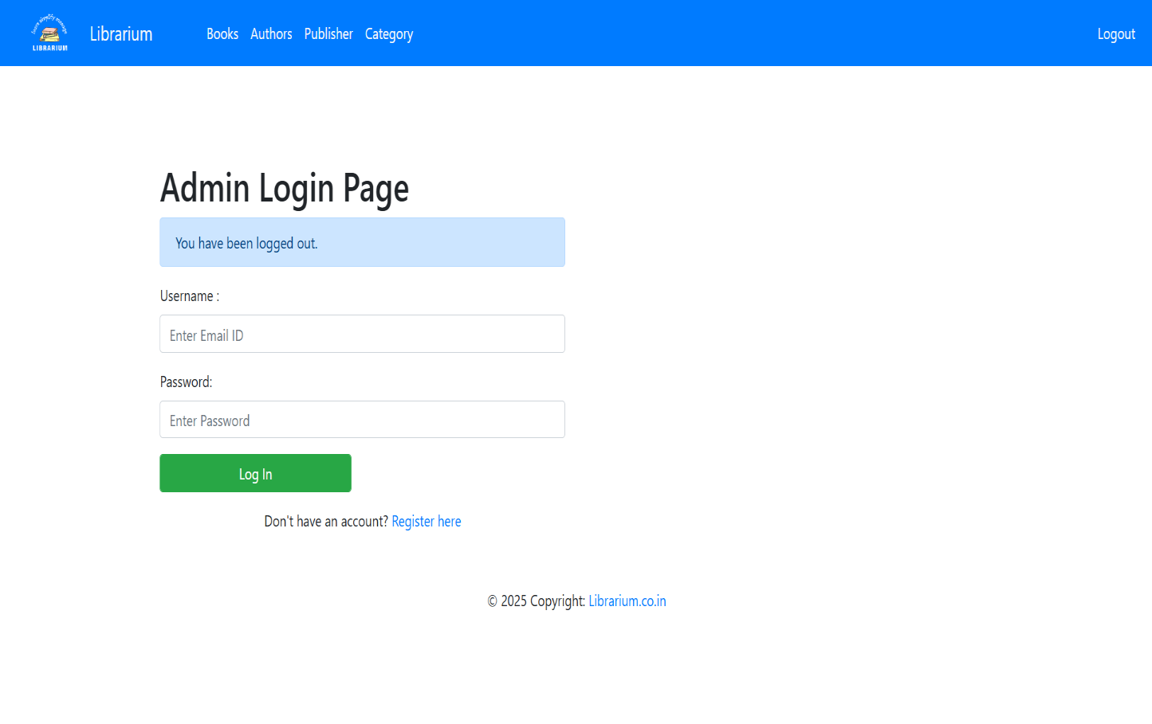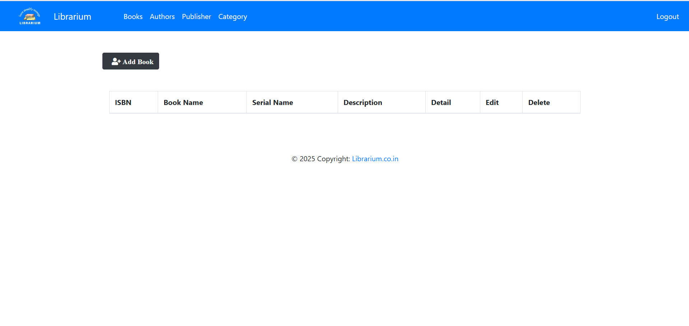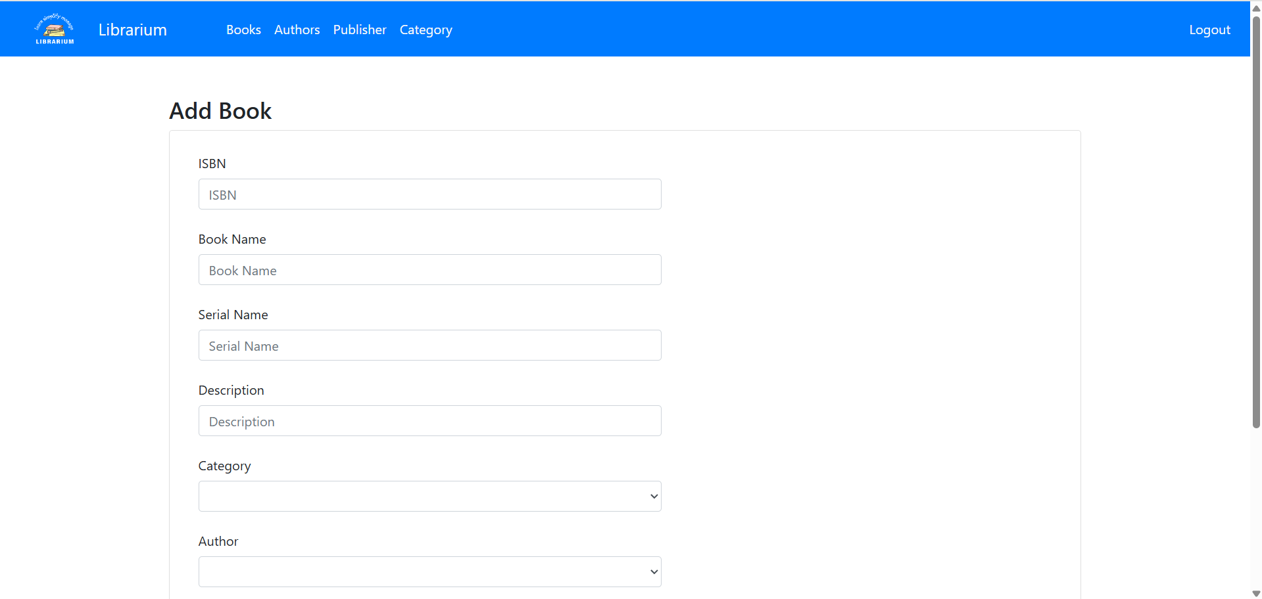

# CHAPTER NINE

## TESTING

##### Introduction

. Testing is a critical phase in the development of a **Library Management System (LMS)** to ensure that all functionalities work correctly, meet user requirements, and maintain system stability. The primary goal of testing is to **identify and fix bugs, improve performance, and enhance security** before deployment. The **testing process** for LMS includes various types of testing such as **unit testing, integration testing, functional testing, usability testing, performance testing, and security testing**.

* **Unit Testing** focuses on individual components or functions, ensuring they work as expected.
* **Integration Testing** verifies that different modules interact correctly.
* **Functional Testing** checks if the system meets all specified requirements.
* **Usability Testing** ensures a user-friendly interface for librarians and members.
* **Performance Testing** examines system speed and response time under load.
* **Security Testing** validates data protection, access control, and vulnerability checks.

By implementing these tests, the **Library Management System** ensures **accuracy, efficiency, and a seamless user experience**.

##### Unit Testing

**Unit Testing** is the process of testing individual functions, classes, or modules in the LMS to ensure they work correctly in isolation. It is typically performed by developers using testing frameworks such as **Jest (for JavaScript), Mocha/Chai (for Node.js), JUnit (for Java), and PyTest (for Python)**.

**1. Unit Testing Objectives:**

* Verify that **each function or component** performs as expected.
* Identify and fix bugs early in development.
* Ensure that changes in one module **do not break** other parts of the system.
* Improve **code quality and maintainability**.

**2. Key Components for Unit Testing in LMS:**

Some critical functions in a **Library Management System** that require unit testing include:

* **User Authentication:** Testing login, registration, and role-based access.
* **Book Management:** Testing book addition, deletion, and search functionality.
* **Borrow & Return Books:** Ensuring borrowing limits, due date tracking, and return processes work correctly.
* **Fine Calculation:** Validating fine calculations for overdue books.
* **Reservation System:** Ensuring users can successfully reserve available books.

# CHAPTER TEN

#### CONCLUSION

The **Library Management System (LMS)** is an essential tool for automating and streamlining library operations. It enhances efficiency by enabling easy book management, user registration, borrowing and returning books, fine calculation, and generating reports. With features like **role-based access control, search and cataloging, reservation system, and overdue tracking**, the system improves the overall experience for both librarians and library members. Additionally, by incorporating **security measures, scalability options, and backup mechanisms**, the system ensures reliability and data integrity.

Despite its advantages, the system has some **limitations** that can be addressed in future enhancements. These limitations primarily relate to system scope, resource constraints, and potential improvements such as **RFID-based tracking, AI-powered recommendations, digital lending, and cloud-based scalability**. Overall, the Library Management System **digitizes library operations, reduces manual workload, and enhances accessibility**, making it an effective solution for modern library management.

##### Project Limitation

While the **Library Management System** provides numerous benefits, it also has some **limitations** that may affect its functionality and scope. These include:

**1. Hardware and Infrastructure Dependency**

* Requires **internet connectivity** for cloud-based versions.
* Needs **barcode scanners or RFID readers** for automation, which may add to costs.
* Performance may degrade with **high server loads** if not optimized.

**2. Limited Advanced Features**

* Does not support **AI-based book recommendations** based on user preferences.
* No built-in **e-book or audiobook lending** system.
* Lack of **voice search or chatbot assistance** for enhanced accessibility.

**3. User and Data Management Constraints**

* Role-based access control is predefined (**Admin, Librarian, Member**) and may need customization for specific libraries.
* System scalability is limited in **self-hosted deployments** compared to cloud-based solutions.
* Might require **manual data migration** when upgrading from older library systems.

**4. Security and Privacy Concerns**

* User data needs **GDPR compliance** for privacy protection.
* Potential **vulnerabilities in authentication and access control** if not properly secured.
* Risk of **data loss** if backup and recovery mechanisms fail.

**5. Integration Challenges**

* Limited integration with **external library networks or national databases**.
* Payment gateways for **fine collection** might not be available in some regions.
* No real-time synchronization with **physical book inventory** unless an RFID system is used.

# CHAPTER ELEVEN

## FUTURE ENHANCEMENTS

To improve the **Library Management System (LMS)** and address its limitations, future enhancements should focus on **automation, user experience, security, and digital transformation**. Below are some key areas for future development:

**1. Automation & Smart Tracking**

✅ **RFID-Based Book Tracking**: Automating book check-in/check-out with **RFID tags** to eliminate manual scanning.  
✅ **QR Code & Barcode Integration**: Allowing users to scan books using mobile apps for quick access and borrowing.  
✅ **Self-Service Kiosks**: Implementing kiosks for **self-checkout and returns**, reducing librarian workload.

**2. Advanced User Experience & Accessibility**

✅ **Mobile App Development**: Creating a **library app** for searching, reserving, and renewing books on smartphones.  
✅ **Voice Search & Chatbots**: Integrating AI-powered **voice search and chatbots** to assist users in book searches.  
✅ **Personalized Book Recommendations**: Using **AI algorithms** to suggest books based on user reading history.  
✅ **Multilingual Support**: Enhancing accessibility by supporting multiple languages in the interface.

**3. Digital Transformation & E-Library Features**

✅ **E-Book & Audiobook Lending**: Integrating digital libraries like **Kindle, Google Books, or Open Library** for online reading.  
✅ **Cloud-Based System**: Enabling **cloud storage and access**, allowing users to borrow books remotely.  
✅ **Virtual Reading Rooms**: Providing online spaces for users to discuss and collaborate on books.  
✅ **Integration with Online Courses**: Linking LMS with **educational platforms like Coursera or Udemy** to enhance learning.

**4. Security & Data Protection**

✅ **Biometric Authentication**: Using **fingerprint or facial recognition** for secure access.  
✅ **End-to-End Data Encryption**: Ensuring user privacy and preventing data breaches.  
✅ **Two-Factor Authentication (2FA)**: Adding an extra layer of security for **admin and librarian logins**.  
✅ **Automated Backup & Recovery**: Implementing **real-time cloud backup** to prevent data loss.

**5. Smart Analytics & Reporting**

✅ **Predictive Analytics for Book Demand**: Using AI to forecast **which books will be in demand** based on trends.  
✅ **Real-Time Dashboard for Admins**: Providing **interactive graphs and analytics** on book circulation and user engagement.  
✅ **Automated Fine Collection System**: Allowing users to pay fines **online via PayPal, Stripe, or digital wallets**.

**6. Integration with External Systems**

✅ **Inter-Library Loan System**: Allowing libraries to **share books across different branches**.  
✅ **API Integration with National Libraries**: Connecting to databases like **WorldCat or Google Scholar** for book availability.  
✅ **Smart Notifications via Email/SMS**: Sending alerts for **due dates, new book arrivals, and overdue fines**.

**7. Sustainability & Green Library Initiatives**

✅ **Digital Membership Cards**: Reducing plastic use by replacing physical cards with **QR code-based digital cards**.  
✅ **Paperless Library Operations**: Implementing **e-receipts and online fine payments** to reduce paper usage.  
✅ **Solar-Powered Library Kiosks**: Installing self-service **solar-powered book return and borrowing stations**.

## REFERENCES

## Website:

## [Librarika: The Free Integrated Library System (ILS)](https://librarika.com/)

## [InvenioILS — inveniosoftware.org](https://inveniosoftware.org/products/ils/)

## [SLiMS - Senayan Library Management System - Beranda](https://slims.web.id/web/)